Steps to View Reports

1. Click On the below link to navigate to Jasper login Screen

http://10.0.5.126:8081/jasperserver-pro

2. Login to Jasper using below details

User:jirauser
Pwd:jira

3. Once you login, it will take you to Jaspersoft home screen. Then go to view→ Repository

4. In the repository section follow the path (root-→Jira-→Reports) to view the reports
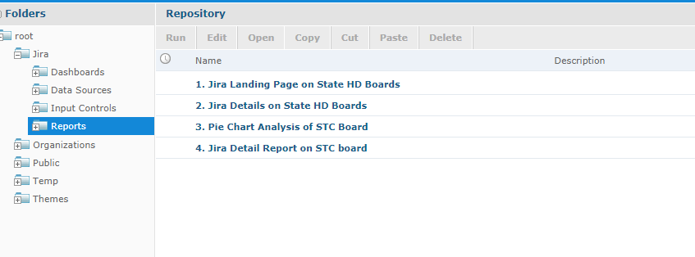

Report Navigation

JiraLandingPage On State HD Boards:
This is a bar chart gives details about statistics on the count of issues across different state boards. We can change the filter to point to different priority issues

JiraDetail On State HD boards:
This is the drill down obtained from the JiraLandingPage. We can view detail info about issues based on priority and state boards

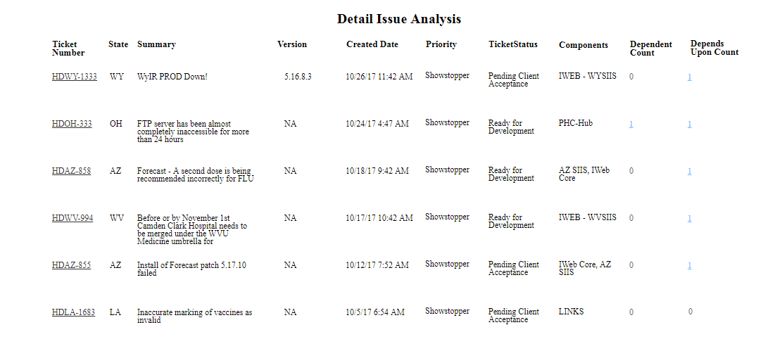

Pie Chart Analysis Of STC Board:
This is a pie chart (drill down from the JiraDetail). It displays statistics on status of depending/depends upon tickets

Jira Detail Report On STC Board:
This is a drill down from InOutIssuePieChart. This gives more details on dependency. You can click on hyperlink to navigate to Jira and view more info

